Introduction to X-Ray Thickness Gauges
As a critical tool in the thickness measurement industry, X-ray thickness gauges are widely acclaimed for their precision and reliability. These gauges utilize X-ray technology to measure material thickness, particularly effective for coatings and thin films. Similar devices, such as β-ray and near-infrared (NIR) thickness gauges, also deliver excellent performance, but X-ray gauges stand out for their versatility and accuracy in specialized applications. For those unfamiliar with this technology, here’s a detailed overview.
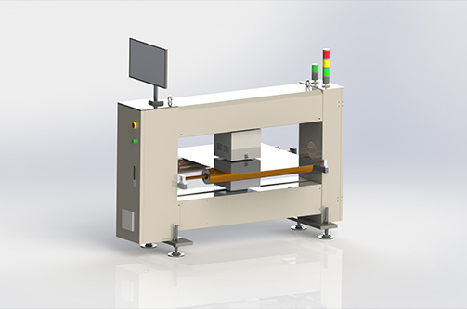

Working Principle
X-ray thickness gauges operate by generating X-rays through photon energy released when electrons collide under high voltage. When external power is supplied, the gauge outputs a high voltage of up to 43 kV, energizing a tungsten filament to emit electrons. These electrons produce a specific spectral energy, which penetrates the material. The thickness is calculated based on the attenuation or reflection of the X-ray beam as it passes through the medium.

Key Features & Applications
- High Accuracy: Ideal for measuring non-magnetic coating thickness on magnetic substrates (e.g., paint on steel).
- Automation & Flexibility:
  - Automated calibration ensures consistent measurement accuracy.
  - Minimal manual intervention required during operation.
- Data Integration: Compatible with computer terminals for real-time data analysis and reporting.

Industry Advantages
X-ray thickness gauges are indispensable in quality control for industries demanding micron-level precision, such as:
- Electronics: Thin film coatings on semiconductors.
- Automotive: Paint and polymer coatings.
- Packaging: Multilayer material thickness verification.

Future Outlook
With advancing measurement technologies and growing demands for precision, X-ray thickness gauges are poised for expanded adoption. Our manufacturer brings decades of expertise in producing high-performance gauges tailored to industrial needs. We welcome inquiries and visits to explore how our solutions can enhance your quality assurance processes.

Why Choose Our X-Ray Thickness Gauges?
- Proven Performance: Trusted by global manufacturers for critical measurements.
- Technical Support: Customizable solutions and seamless integration with production lines.
- Innovation-Driven: Continuous R&D to meet evolving industry standards.
Visit us to experience cutting-edge thickness measurement technology firsthand.

