Why Choose Reechi Online Thickness Measurement Systems?
Core Advantages
- Precision and Repeatable Measurement Sensors
- Advanced Measurement Software with Scientific Algorithms and Enhanced Functionality

Superior Performance: Accuracy and Repeatability
- X-ray Measurement Sensor with Domestic Leading Technology: Developed by nuclear detection experts with 20+ years of experience.
- Dual Closed-Loop Control for emitter and detector, ensuring automatic calibration and compensation.
- Ultra-Fast Sampling: 1 ms sampling frequency and 2–10 ms response time.
- High-Resolution Design: Collimated X-ray beam with an 8.5 mm spot diameter.
- Innovative Engineering: Soft start/stop technology and 5–7 year lifespan design.

Optimized System Design
- Scientific Measurement Algorithms: Provides 1 mm sampling distance for point-specific data.
- Data Noise Reduction: Minimizes system errors caused by over-smoothing.
- Professional Electrical Design: Unique data communication and acquisition methods ensure synchronized measurement and positional accuracy.
- Robust Mechanical Structure:
  - High-rigidity O-frame scanning system.
  - Precision linear motion modules.
  - Reechi’s synchronized dual-probe movement system for stable and reliable measurements.
  - 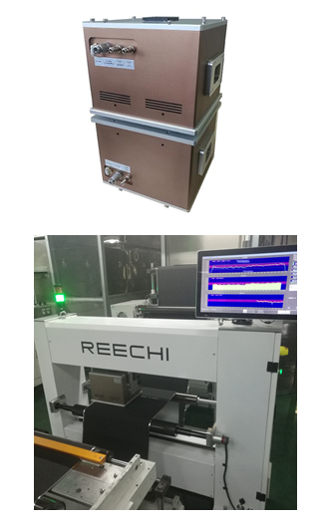

Powerful Software System with Advanced Algorithms
- Collaborative Development: Designed by software architects, big data experts, and quality engineers.
- Key Features:
  - Real-time thickness monitoring and multi-line quality control.
  - Remote Monitoring: Multi-device control, data management, and customizable curve display (requires client-provided PC and monitor).
  - Big Data Platform: Full-process data storage and SPC statistical analysis.
  - MES Integration: Supports closed-loop control via pre-installed communication interfaces.

User-Friendly Design for Enhanced Experience
- Intuitive Operation:
  - One-click intelligent controls and error-proof design.
  - Simplified workflow – master the system in 10 minutes.
- Flexible Configuration:
  - Multiple measurement modes and parameters integrated into a unified software interface, eliminating complex traditional operations.
  - Customizable Software: Continuously adapts to evolving client requirements.

