Radiation Protection Guidelines for β-Ray Thickness Gauges

I. National Radiation Safety Standards
In accordance with China’s Basic Standards for Protection Against Ionizing Radiation and the Safety of Radiation Sources (GB 18871-2002, issued October 8, 2002):
- Occupational Exposure Dose Limits:
  - Annual average effective dose over any consecutive 5 years (no retrospective averaging): 20 mSv.
  - Effective dose in any single year: ≤ 50 mSv.
  - Annual equivalent dose to the lens of the eye: ≤ 150 mSv.
  - Annual equivalent dose to extremities (hands/feet) or skin: ≤ 500 mSv.

II. Comparison of Common Radiation Exposure in Daily Life
- Air travel: 1.1 mSv per 10 hours.
- Medical imaging:
  - Chest X-ray: 1.1 mSv per procedure.
  - Standard radiography: 0.2 mSv per scan.
- CT scans:
  - Brain: 2 mSv.
  - Chest: 8 mSv.
  - Abdomen: 10 mSv.
- CAT angiography: 15 mSv per procedure.

III. Radiation Protection Management Requirements
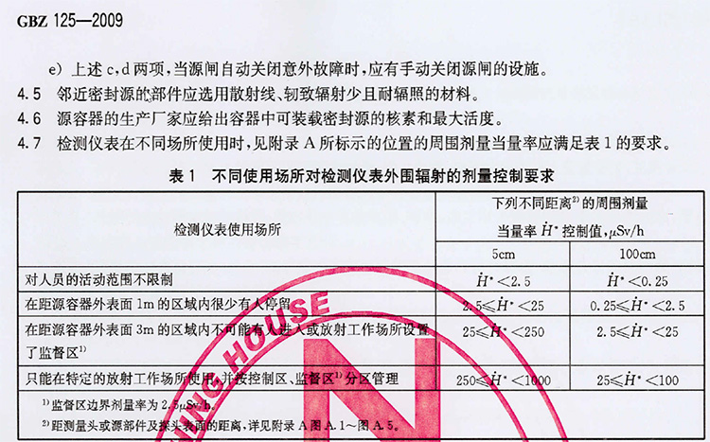
IV. Radiation Exemption Criteria
A2. Exemptible Sources and Exemption Levels
A radiation source may be exempted from regulatory requirements if approved by authorities under the following conditions:
- Radiation generators or electronic devices (e.g., cathode ray tubes) must meet:
  - Dose rate: ≤ 1 μSv/h (ambient or directional dose equivalent rate at 0.1 m from any accessible surface).
  - Maximum photon energy: ≤ 5 keV.

V. Three Principles of Personal Radiation Protection
- Distance Protection:
Radiation intensity decreases with distance. Maintain ≥1 meter from the source to minimize exposure.
- Shielding Protection:
Use shielding materials (e.g., concrete, iron, or lead) to block radiation.
- Time Protection:
Limit exposure time. Avoid prolonged close contact (>2 hours). Post-exposure recovery includes rest and a high-protein diet.

VI. Reechi β-Ray Thickness Gauge Protective Enclosures
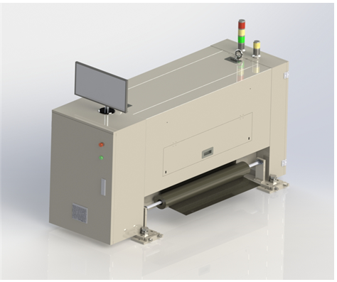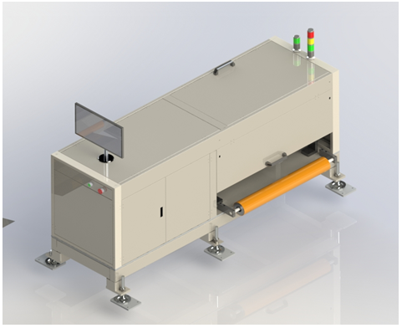
Reechi β-Ray Thickness Gauge (O-Frame) Reechi β-Ray Thickness Gauge (C-Frame)

